Civil war in Somalia

UNSC Resolution: | 837
Date of adoption: | 6-Jun-1993
Operative paragraph: | 4
Demand number: | 837,0411

Sarah-Myriam Martin-Brulé

Wording of demand
- comply fully with the commitments undertaken in the agreements concluded at the informal Preparatory Meeting on Somali Political Reconciliation in Addis Ababa, and in particular with the Agreement on Implementing the Cease-fire and on Modalities of Disarmament (S/25168, annex III)

List of addressees of the demand
- Government of Somalia, United Somali Congress Faction

Short-term compliance

Description of the addressee(s)’ conduct

Throughout June, July, August and September, UNOSOM II forces, including U.S. forces working with UNOSOM contingents, made efforts to capture Aideed and other key SNA personnel in accordance with UNSC Resolution 837. SNA forces countered by conducting ambushes of UNOSOM forces in which armed attackers were shielded by civilians, especially women. Peacekeepers from Italy, Pakistan, Nigeria, the United States, and Morocco, as well as hundreds of Somalis, died during such incidents. In
September and October, SNA rocket and mortar attacks on the U.N. facility and U.S. Liaison Office in South Mogadishu became more frequent. SNA forces unlawfully detained two peacekeepers, a Nigerian and an American (see Section 1.d.),
the American after an attack October 3 on an SNA stronghold in Mogadishu.

U.S. DEPARTMENT OF STATE. “SOMALIA HUMAN RIGHTS PRACTICES, 1994
JANUARY 31, 1995 U.S. DEPARTMENT OF STATE.
http://dosfan.lib.uic.edu/ERC/democracy/1994_hrp_report/94hrp_report_africa/Somalia.html

“10. Although General Aidid declared a cease-fire on 9 October 1993, he was subsequently quoted as having stated in an interview that the presence of UNOSOM troops was undesirable and had become an obstacle to any political solution in Somalia. 4/ This statement was made in spite of ongoing efforts by senior United Nations officials, including a visit by the Secretary-General to Somalia on 22 October 1993, aimed at achieving implementation of the Addis Ababa Agreement. Later on, it was reported that the cease-fire had broken down and that clan feuding had started up again in Mogadishu.”
(...)
“19. The expert therefore deplores the fact that despite several calls from the Security Council 11/ for a comprehensive and effective programme for disarming of the Somali parties, including movements and factions, the Somali leaders continue to violate the commitments they made on 27 March and 1 October 1993, notwithstanding their request to UNOSOM to apply strong and effective sanctions against those responsible for any violation of the Cease-Fire Agreement. Furthermore, the Somali leaders have reiterated that to find a genuine and lasting solution to the Somalia crisis, the cooperation of UNOSOM II with the political organizations and community leaders is essential for the fulfilment of the Addis Ababa Peace Agreement.”

Item 19 of the provisional agenda
ADVISORY SERVICES IN THE FIELD OF HUMAN RIGHTS, Report by the independent expert, Mr. Fanuel Jarirentundu Kozonguizi, on the conditions in Somalia, prepared in accordance with paragraph 6 of Commission on Human Rights resolution 1993/86 E/CN.4/1994/77
15 December 1993, COMMISSION ON HUMAN RIGHTS. Fiftieth session

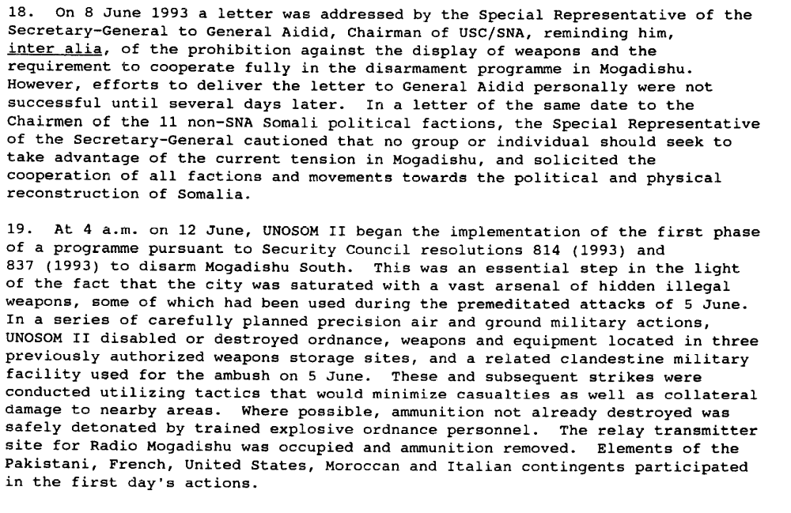

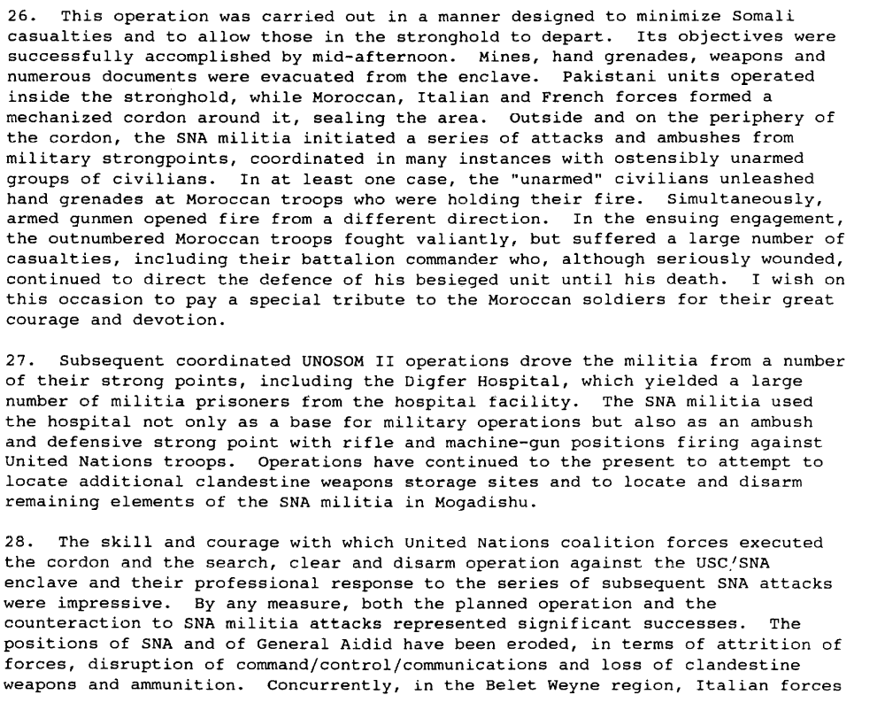

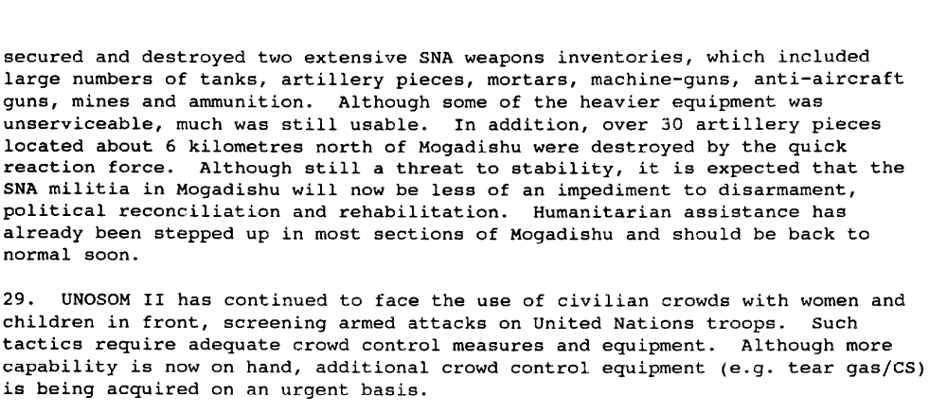

Report of the Secretary-General on the Situation in Somalia, S/26022

Meanwhile, on 4 September, Jonathan Howe decided to try negotiating a forty-eight hour truce with Aideed and the SNA. The next day still another ambush by Aideed’s militiamen killed seven Nigerians.22 On 6 September, through a cable to the State Department, Ambassador Gosende urged a tough response: shelve plans for negotiating a truce; expand Task Force Ranger’s mission to include capturing Aideed’s lieutenants, and mount a major sweep, using additional forces, into Mogadishu’s most troublesome areas. General Hoar disagreed completely, and he immediately told Chairman Powell why. Unless UNOSOM either significantly changed its strategy or dramatically improved its command and control capabilities, Hoar argued, US forces would have to stay indefinitely and incur a “potential for additional mission creep.” In Hoar’s judgment,
UNOSOM had lost control over Mogadishu.

Walter Poole. Efforts to Save Somalia: March 1992-August 1994.
http://www.dtic.mil/doctrine/jel/history/somalia.pdf

1993 9 October USC/SNA declare a unilateral cessation of hostilities against UNOSOM II forces. (ISS database)

Assessment

Short-term compliance
X No or marginal compliance (1) | Medium low compliance (2) | Medium high compliance (3) | Full or almost full compliance (4)

Considerations underlying the assessment

Within the six months following the adoption of the resolution, the demand addressees did not comply fully with the commitments undertaken in the agreements concluded at the informal Preparatory Meeting on Somali Political Reconciliation in Addis Ababa, and in particular with the Agreement on Implementing the Cease-fire and on Modalities of Disarmament (S/25168, annex III).

Medium-term compliance

Description of the addressee(s)’ conduct
19. The expert therefore deplores the fact that despite several calls from the Security Council / Security Council resolutions 814 (1993) of 26 March 1993, para. 8; 837 (1993) of 6 June 1993, para. 3 and 865 (1993) of 22 September 1993, eleventh preambular paragraph./ for a comprehensive and effective programme for disarming of the Somali parties, including movements and factions, the Somali leaders continue to violate the commitments they made on 27 March and 1 October 1993, notwithstanding their request to UNOSOM to apply strong and effective sanctions against those responsible for any violation of the Cease-Fire Agreement. Furthermore, the Somali leaders have reiterated that to find a genuine and lasting solution to the Somalia crisis, the cooperation of UNOSOM II with the political organizations and community leaders is essential for the fulfilment of the Addis Ababa Peace Agreement

ADVISORY SERVICES IN THE FIELD OF HUMAN RIGHTS, Report by the independent expert, Mr. Fanuel Jarirentundu Kozonguizi, on the conditions in Somalia, prepared in accordance with paragraph 6 of Commission on Human Rights resolution 1993/86 E/CN.4/1994/77
15 December 1993, COMMISSION ON HUMAN RIGHTS. Fiftieth session
http://www.unhchr.ch/Huridocda/Huridoca.nsf/TestFrame/1a466097122271a98025672b005c92ae?Opendocument

Assessment

Medium-term compliance
X No or marginal compliance (1) | Medium low compliance (2) | Medium high compliance (3) | Full or almost full compliance (4)

Considerations underlying the assessment

Within the two years following the adoption of the resolution, the demand addressees did not comply fully with the commitments undertaken in the agreements concluded at the informal Preparatory Meeting on Somali Political Reconciliation in Addis Ababa, and in particular with the Agreement on Implementing the Cease-fire and on Modalities of Disarmament (S/25168, annex III).

Depth of demand

Assessment

Level of depth of demand
Low depth of demand (1) | Medium depth of demand (2) | X High depth of demand (3)

Considerations underlying the assessment

Jonathan Howe, who held a UN post but exploited his ties with top US officials to the utmost, despised Aideed and believed that eliminating him would vastly ease problems of political reconstruction. Ambassador Gosende, who also detested Aideed, looked for ways to achieve Howe’s objective while backing away from some of Howe’s confrontational methods.

Walter Poole. The Effort to Save Somalia: March 1992-August 1994.
http://www.dtic.mil/doctrine/jel/history/somalia.pdf

“The SNA was named in the resolution and thereby became the enemy of UNOSOM and the US military, although Aideed’s name was dropped after appearing in an early draft resolution”
John Hirsh & Robert B. Oakley. 1995. Somalia and Operation Restore Hope: Reflections on Peacemaking and Peacekeeping. USIP.

Level of confidence about coding decisions

Level of confidence about coding decision
Extremely high | X High | Moderate

Comments to IPI (if any)

